1.Write a C++ program for calculate the area of the rectangle and the volume of the rectangle. Create a class area and derive the class volume and use the same member function with same parameters for the above classes.

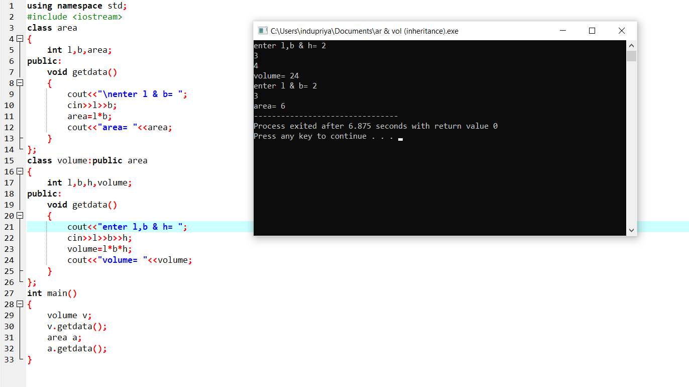

2.Write a C++ program for the following inheritance.Get rate of interest of SBI,ICICI,AXIS banks and total bank interest.

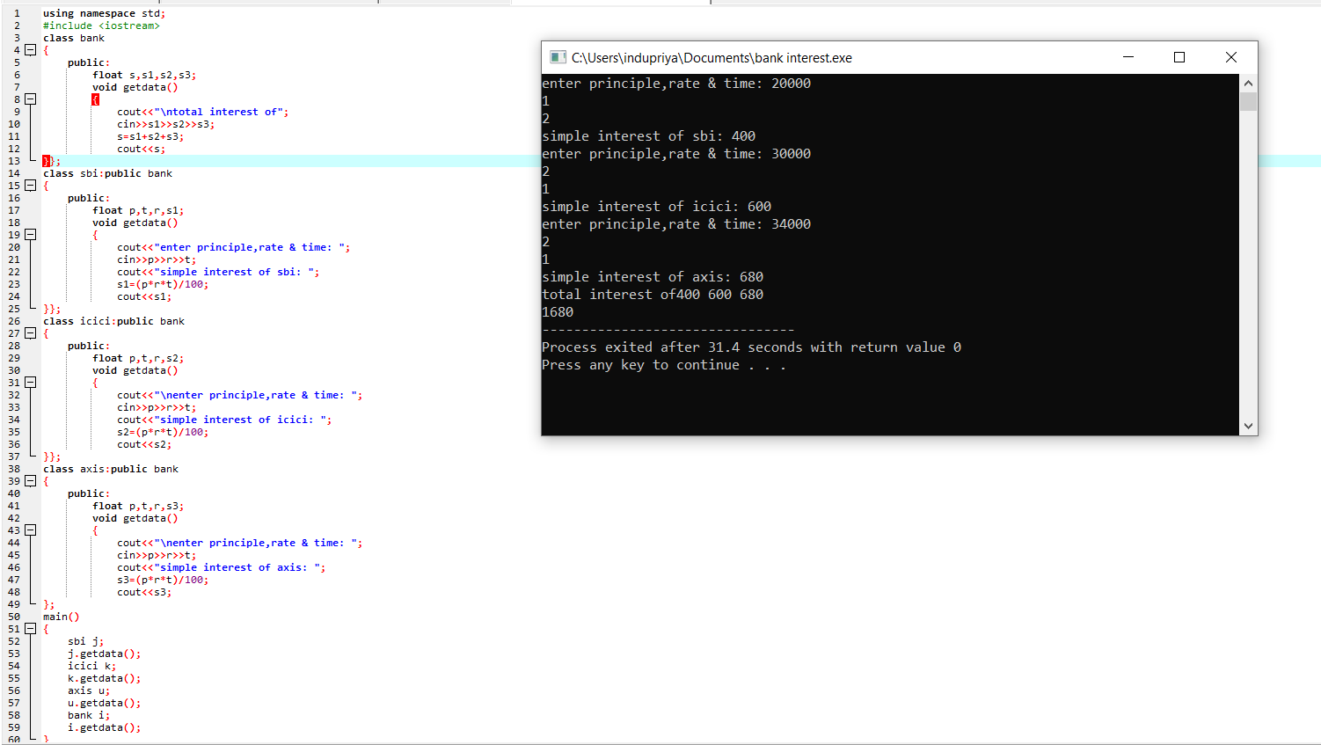

3.Write a C++ program for divisor by zero.

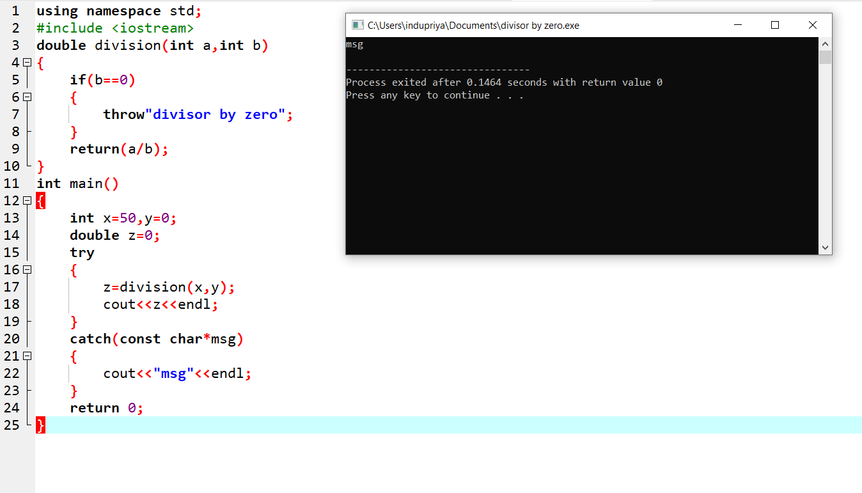

4.Write a C++ program for polymorphism.

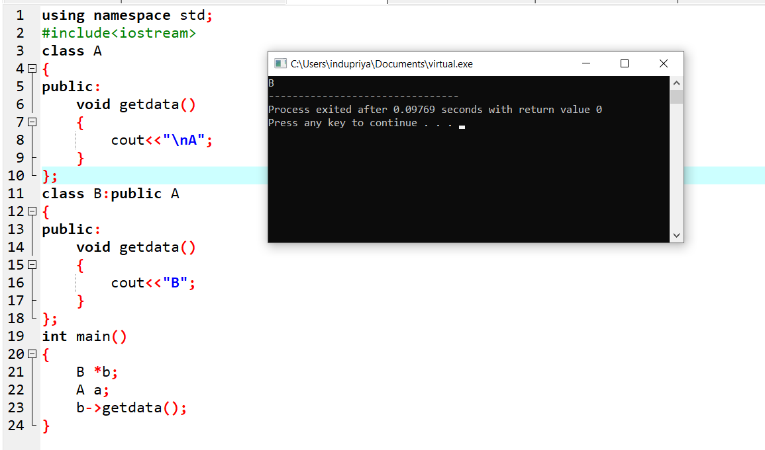

5.Write a C++ program for user-defined exception.

